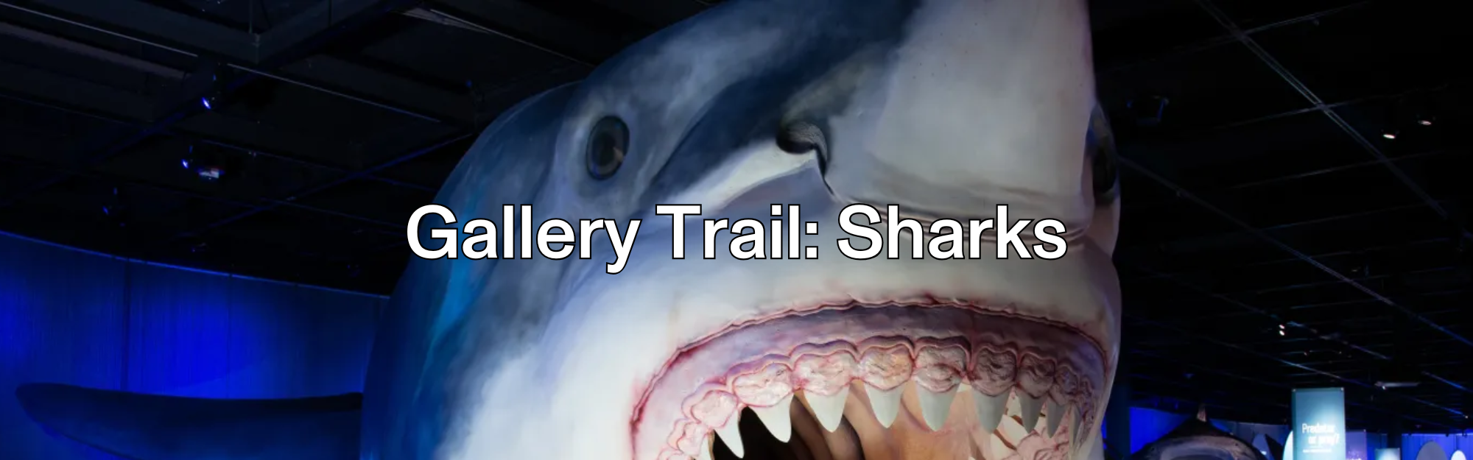
Welcome to Sharks!
Humans have been curious about sharks for as long as we have explored the oceans. The terrifying monster from the movie Jaws is what many might imagine when they think of these animals, but they are far more fascinating and complex than what you might see in the movies.
Explore the exhibition to learn more about sharks, their habitats, how they hunt, and their threats.
- Use any objects you like to help you answer the questions on this gallery trail.
- You can work in small groups on the questions and the activities.
- Remember that you’re sharing the space with other people. Be respectful.
- Choose a working space that doesn’t block someone’s view or path.

Please use pencils and not pens to keep the objects and belongings safe.

Before you visit:

✎ Write down 5 things you think you know about sharks.

1.

2.

3.

4.


5.

Shark Science
✎ As you go through the exhibition, you’ll learn about many different sharks and their relatives. Become a shark scientist and fill in the table below.

Compare and contrast what you notice and learn about two different sharks and one shark relative.It’s okay if you can’t fill in every single box in the table during your visit!

Discover…. | Animal 1 (shark) | Animal 2 (shark) | Animal 3 (relative)
What’s it called?
How big is it?
What does it look like?

What and how does it eat?
What’s interesting about it?
How does it interact with other animals?
What threatens it?

BACK IN CLASS: Do some research to fill in any empty spots on the table.

Amazing Adaptations
✎ Adaptations are something an animal has on its body or ways that an animal behaves that help it survive better in its natural habitat.

Choose one shark or shark relative that you learned about in the exhibition.
- Sketch the animal
- Label the adaptations that help it survive
- Explain how each adaptation helps it survive

BACK IN CLASS: Turn your diagram into a fancy label for a museum exhibition. Combine your class labels into your own class Sharks Exhibition!
Under Threat
✎ Sharks face many threats. Some are predators in the ocean, but many are human activities. Write down some of the threats you learned about:

BACK IN CLASS: Spread the Word
Write an article or create a poster to inform people about some of the threats sharks face. You may want to include:
- What are the threats?
- How do they affect sharks?
- Why does it matter?
- What could people do to help save sharks?

Now I know….
✎ Look back at the 5 things you wrote about sharks on page 1. Did anything change?

Explain how the exhibition changed what you thought you knew about sharks.

What are your favourite things that you learned?

BACK IN CLASS: A Shark Tale
✎ Using everything you learned in this exhibition, tell the story of the life of a shark

Your story could be:
- A written story
- A comic
- A digital storybook (using Slides, Prezi, Canva, or another app)
- Another format that tells your story best.

Things to think about:
- Where does your shark live?
- How does it get around?
- What does it eat?
- What other animals does it meet?
- What challenges does it face?

Share your stories with us @ROMtoronto

