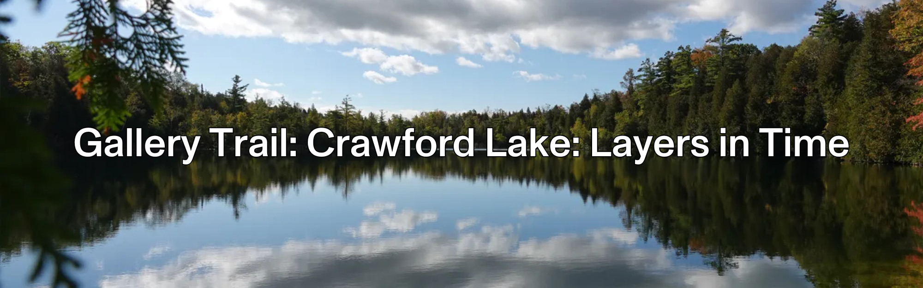
Welcome to Crawford Lake
For more than 55 years, scientists have studied Crawford Lake to identify what is recorded. In July 2023, the lake was selected as the world’s best marker of a proposed new geological time period defined by human-caused change, the Anthropocene.
Get to know this surprising body of water and the stories it can tell about our past, present, and future.
- Use any objects you like to help you answer the questions on this gallery trail.
- You can work in small groups on the questions and the activities.
- If you’re at the museum:
  - Remember that you’re sharing the space with other people. Be respectful.
  - Choose a working space that doesn’t block someone’s view or path.

Please use pencils and not pens to keep the objects safe.

Before you start

✎ Write down 5 ways you think that humans have affected the Earth in the past and the present.

1.

2.

3.

4.


5.

Why Does it Matter?

Explore the introduction to the exhibition, and the core display in the middle of the room. In your own words, explain why the research done at Crawford Lake is important enough to make an exhibition about it.
What is a Core?

Explore the core display in the middle of the room. Sketch the Crawford Lake core below, and add at least three labels explaining important features on the core.

Gathering Evidence

Choose 3 sections in the exhibition. For each one, write down which section you chose, explain what evidence is found in the core, and what that evidence tells us about how humans have affected the Earth.
Section | What evidence is in the core? | What does that tell us about how humans affected the Earth?
Reflect and Revise

Look back at your list of 5 ways humans affect the Earth. After learning in this exhibition, what were you right about? What were you wrong about? What new things did you learn?
BACK IN CLASS: Visions of the Future

Based on everything you learned in the exhibition, imagine one idea people could do to reverse some of the harmful impacts we have had on the planet.

Imagine you are a news reporter in the future, after people started doing your idea. Design a news article explaining:
- what was done
- what things were like before your idea took effect
- how your idea changed the world.

Be sure to include before and after illustrations.
Use the space below to take notes for your article.

DIG DEEPER: Assemble your class articles into a newspaper from the future.

Share your stories with us @ROMtoronto

